Eight Clusters, One Discrete Assignment
A Critical Analysis of Clustering, Evidence, and Mechanistic Interpretation in a Multi-Ancestry T2D GWAS
A critical analysis of “Genetic drivers of heterogeneity in type 2 diabetes pathophysiology”
Suzuki, Hatzikotoulas, Southam, et al. (2024), Nature, 627, 347–357

Sheryl S.
Research Portfolio Series · Critical Analysis #01
August 2026

Table of Contents
1. Central Claim and Evidentiary Overview 3
2. Theoretical Foundation 3
3. Data and Study Design 5
4. Clustering Methodology — The Central Critique 5
4.1 Hard Assignment and the Pleiotropy Problem 5
4.2 ClustImpute and Sensitivity to Missing Data 6
4.3 Hard vs. Soft Clustering 6
5. Chromatin Accessibility Evidence 7
6. Partitioned Polygenic Scores: Detectability vs. Predictive Value 8
7. Ancestry Representation and Generalizability 8
8. Strengths and Limitations 9
9. Reproducibility 10
10. My Critical Perspective 10
11. What Would Change My Mind 11
12. Potential Research Extensions 11
13. Questions the Paper Leaves Open 12
14. Lessons Learned 12
15. Connection to My Development as a Bioinformatician 12
16. Conclusion 13
References 13

1. Central Claim and Evidentiary Overview
This paper argues that T2D genetic risk is not a single undifferentiated signal. It assembles GWAS data from 2,535,601 individuals across six ancestry groups (39.7% not of European ancestry), identifying 1,289 independent association signals mapping to 611 loci, 145 of them novel. On top of this, the authors cluster the 1,289 signals into eight groups based on their pattern of association with 37 cardiometabolic traits, show that these clusters are enriched in cell-type-specific open chromatin, and build cluster-specific (“partitioned”) polygenic scores that associate with vascular outcomes in independent samples.
The logical chain here runs: statistical association (GWAS) → statistical clustering (k-means on trait profiles) → regulatory plausibility (ATAC-seq enrichment) → phenotypic relevance (partitioned PS vs. outcomes). Each link licenses a different strength of claim. The paper provides real evidence for the first three; it does not establish a demonstrated molecular mechanism or clinical utility for the fourth and fifth. That distinction organizes this analysis, and the clustering step gets the closest scrutiny, because every later stage of the pipeline conditions on the eight-cluster partition without independently re-testing it.
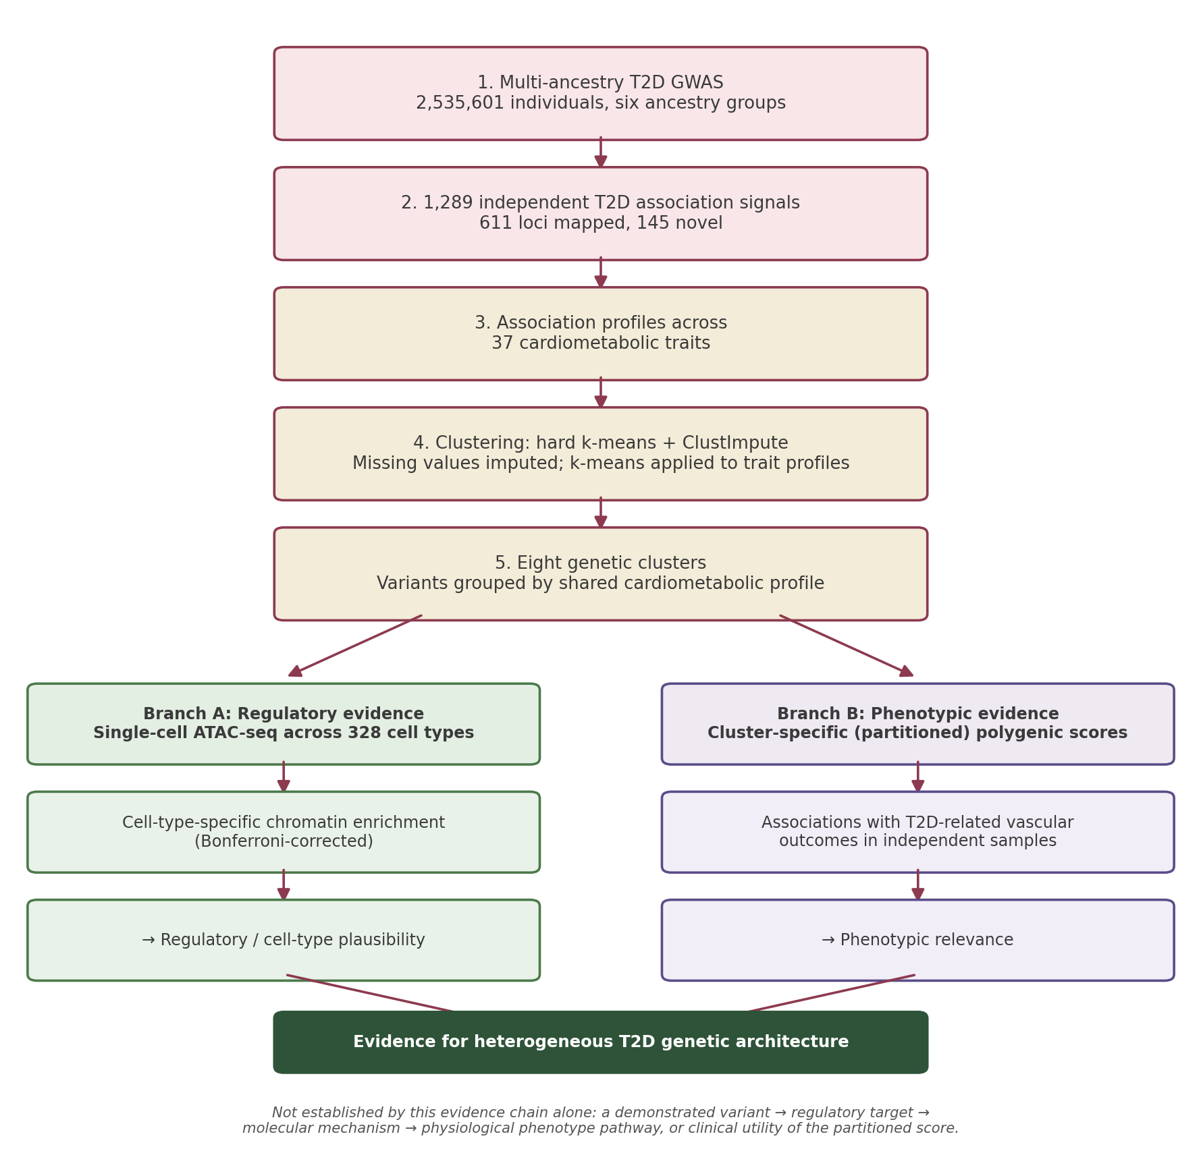
Figure 1. From multi-ancestry GWAS signals to biological and phenotypic evidence. Diagram constructed by the author to summarize the paper's evidence chain; not reproduced from the original publication.

2. Theoretical Foundation
This section covers only the concepts needed to follow the critique that follows — not a general GWAS primer.

2.1 Multi-Ancestry Meta-Regression (MR-MEGA)
Standard fixed-effects meta-analysis assumes a variant's true effect is identical across every contributing study, treating any observed differences as sampling noise. That assumption is questionable across ancestry groups, where allele frequencies, LD structure, and possibly the underlying biology differ. MR-MEGA instead models allelic effects as a function of continuous axes of genetic variation — principal components built from a distance matrix of allele-frequency differences between studies — so ancestry-correlated effect heterogeneity is absorbed into the regression rather than forced into one pooled estimate. This is what makes the paper's later ancestry-heterogeneity analysis possible at all. The trade-off is that MR-MEGA does not itself yield a single interpretable effect size per SNV, so the authors ran a separate fixed-effects meta-analysis for that purpose. Genomic control inflation was lower under MR-MEGA (λᴳᶜ = 1.120) than fixed-effects meta-analysis (λᴳᶜ = 1.396), consistent with MR-MEGA accounting for ancestry-correlated heterogeneity that contributes to inflation, though this is a global diagnostic and does not certify any individual locus's heterogeneity classification.

2.2 Hard k-Means Clustering and What It Discards
k-means assigns each of the 1,289 index SNVs, represented by z-scores of association with 37 phenotypes, to whichever of k cluster centroids it sits closest to. Two properties matter for everything downstream. First, k-means is a hard-assignment method: every SNV lands in exactly one cluster, and the output carries no information about how close that assignment was. Second, k-means requires complete data, and this phenotype matrix is not complete. Missing GWAS summary statistics were filled in using ClustImpute before clustering could run.
ClustImpute works iteratively. In the first pass, missing z-scores are imputed at random from each phenotype's marginal distribution and k-means is run once. In each subsequent pass, missing values are re-drawn based on the SNV's current cluster assignment, with a penalizing weight on these imputed draws that shrinks them toward the global feature mean early on and is faded out over a fixed number of iterations as cluster assignments become more reliable. This means a SNV's final cluster membership and its imputed phenotype values are not estimated independently — they co-evolve across iterations.

2.3 What Partitioning a Polygenic Score Changes
An overall T2D polygenic score sums risk-allele dosage across all associated variants, weighted by GWAS effect size, into one number representing total genetic liability. A partitioned PS instead sums only the variants in one cluster, producing a separate score per cluster per individual. Testing whether a cluster-specific score associates with an outcome after adjusting for the overall PS asks a narrower question than testing the overall PS alone: not “does genetic risk predict this outcome,” but “does knowing which pathway a person's risk routes through add information beyond total burden.” That distinction matters for how the results in Section 6 should be read.

2.4 ATAC-seq Enrichment: What It Can and Cannot Show
ATAC-seq identifies regions of accessible, nucleosome-depleted chromatin — a reasonable proxy for DNA actively used for gene regulation in a given cell type, since regulatory proteins generally need open chromatin to bind. Finding that a cluster's SNVs are enriched in cell-type-specific open chromatin is genuine evidence that those variants have a plausible route to regulatory activity in that cell type. It does not identify which gene is being regulated, whether the effect is activating or repressing, what magnitude of expression change results, or whether that change causes the phenotype the cluster was built to represent. Open chromatin is closer to a precondition for regulatory action than to proof of it.

3. Data and Study Design
Reconstructed as a pipeline: assemble ancestry-labeled GWAS summary statistics → run MR-MEGA and per-ancestry fixed-effects meta-analyses → define index SNVs and loci at genome-wide significance → cluster index SNVs by their 37-phenotype association profile, imputing missing values via ClustImpute → test cluster enrichment against independent single-cell ATAC-seq atlases → build overall and partitioned polygenic scores in a separate, non-overlapping sample and test their association with vascular outcomes and age of onset → extend the two strongest clusters into an independent set of clinical trial cohorts.
A few data details matter for what follows. Ancestry composition of the discovery meta-analysis: EUR 60.3% of effective sample size, EAS 19.8%, AFA 10.5%, HIS 5.9%, SAS 3.3%, SAF 0.2% — the most ancestry-diverse T2D meta-analysis to date, though still EUR/EAS-dominated. The partitioned-PS testing sample (279,552 individuals) is explicitly independent of the discovery meta-analysis, which matters directly for how much weight the outcome associations in Section 6 can bear. The paper also investigates whether ancestry-correlated heterogeneity in allelic effects is attributable to differences in the BMI distribution of cases and controls between ancestry groups, adjusting for study-level mean BMI — an ecological, group-level covariate that cannot fully substitute for individual-level genotype × BMI or environmental-exposure analysis. This point resurfaces in Section 7.
On the genome-wide significance threshold: the DIAMANTE Consortium had argued multi-ancestry meta-analysis breaks down LD structure and increases the effective number of independent tests, warranting a stricter threshold (5×10⁻⁹) than the conventional 5×10⁻⁸. The authors test this empirically — 36 of 39 DIAMANTE loci that were significant only at the looser threshold reach significance again with this study's larger sample — and use that as justification for the conventional threshold. This is a reasonable empirical argument for signals with a prior study to check against, though it does not fully resolve the concern for loci that are novel to this analysis.

4. Clustering Methodology — The Central Critique
Everything downstream — chromatin enrichment, partitioned polygenic scores, the framing of “mechanistic clusters” — conditions on the eight-group partition being a reasonably faithful representation of the data's structure. None of the later stages independently re-derives or stress-tests that partition; they all take it as given.

4.1 Hard Assignment and the Pleiotropy Problem
T2D risk variants are well documented to be pleiotropic. A variant near IGF2BP2, for instance, could plausibly influence both insulin secretion and adiposity through partly independent pathways, and several of this paper's own clusters (metabolic syndrome, obesity) already combine multiple phenotype signatures — fasting glucose, fasting insulin, WHR, triglycerides, HDL, blood pressure — into one label. Under hard k-means, a variant with a genuinely intermediate profile is not flagged as intermediate; it is assigned to whichever single cluster its centroid distance happens to be smallest to, and that assignment then feeds unmodified into the chromatin-enrichment and partitioned-PS analyses.
The authors offer one indirect check on this: they compare the disparity around the centroid for the three newly identified clusters against the five previously reported clusters and find no noticeable difference, taking this as evidence that forcing all SNVs into one cluster did not introduce substantial additional noise. This compares average within-cluster tightness between old and new clusters; it does not report, for any individual SNV, its distance to a second-nearest centroid. A cluster can have a tight average centroid distance and still contain a meaningful minority of borderline members. From the material available for this analysis, I could not determine what fraction of the 1,289 index SNVs have a near-tied or ambiguous cluster assignment.
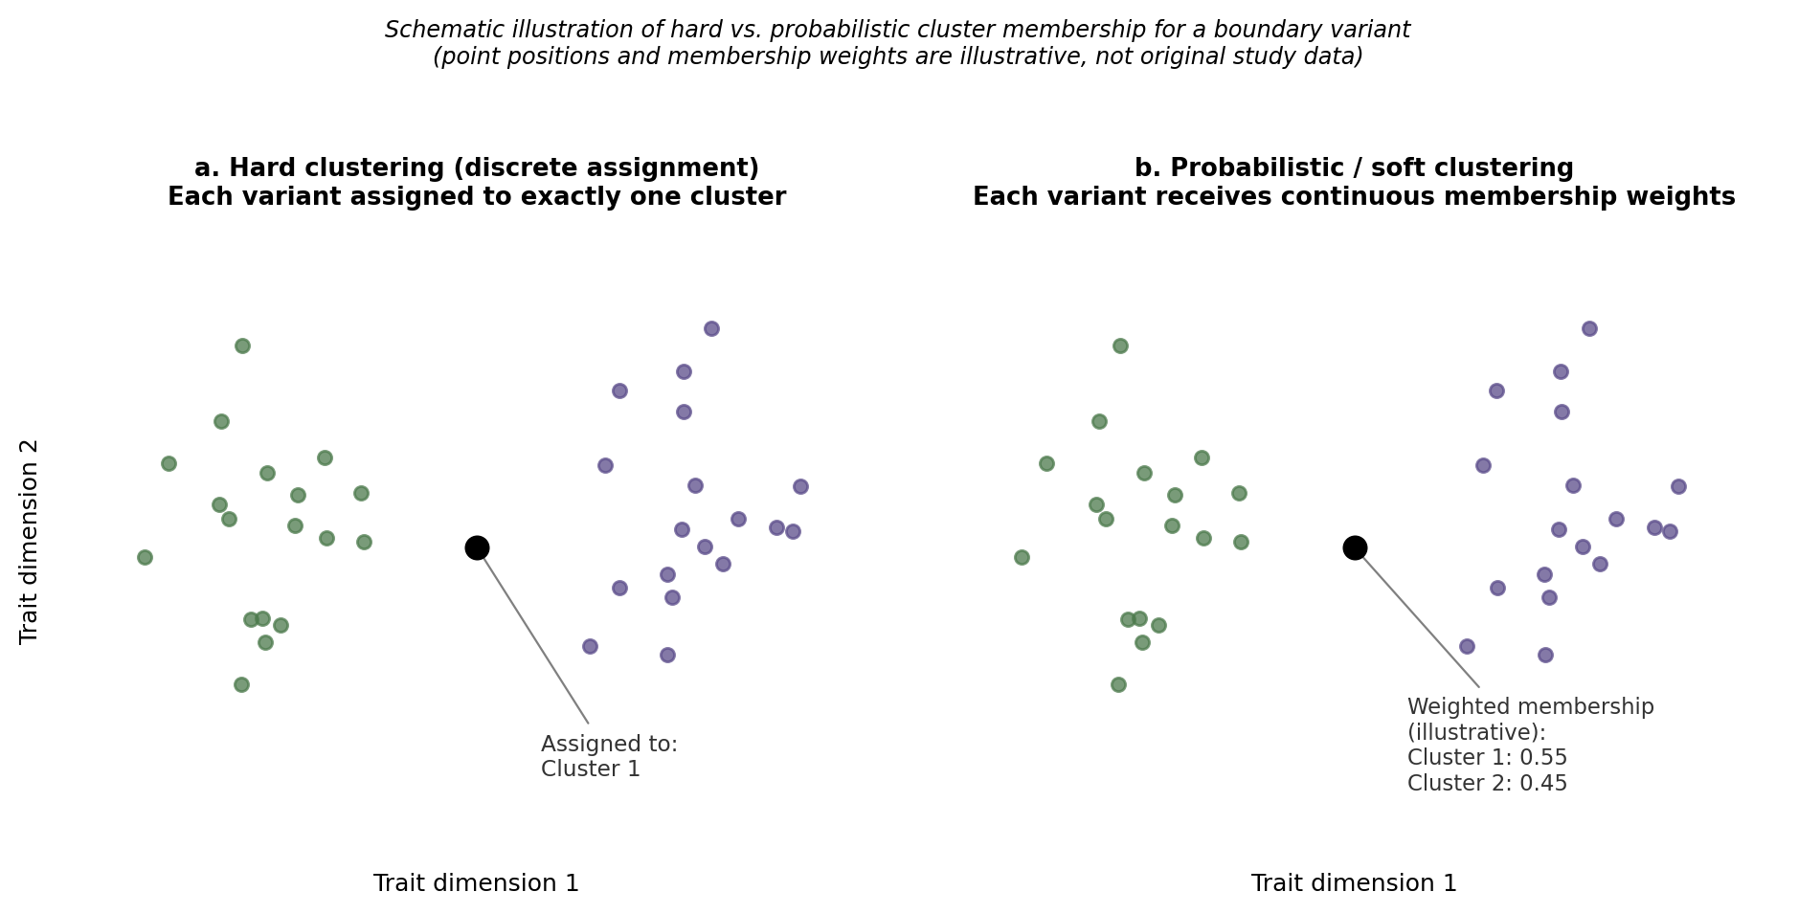
Figure 2. Hard versus soft cluster membership for a boundary variant. Schematic illustration only — point positions, cluster geometry, and membership weights are illustrative and do not represent the original study data.

4.2 ClustImpute and Sensitivity to Missing Data
Because later iterations of ClustImpute re-impute missing phenotype values conditional on a SNV's current cluster assignment, a SNV with substantial missing phenotype information has more of its final phenotype-space position shaped by the imputation-clustering process itself than a SNV with a nearly complete profile does. This is not an invalid procedure — conditioning imputation on correlated cluster structure is a recognized approach to clustering with missing data, and the authors are transparent about the mechanism. The concern is narrower: without per-SNV or per-phenotype missingness rates, it is not possible to tell from the material available whether smaller clusters — liver and lipid metabolism, with only 3 signals, or lipodystrophy, with 45 — are small because they represent a genuinely rare and distinct physiological signature, because sparse phenotype data interacted with the imputation-clustering loop, or some combination of both. This is a testable concern, not an established explanation, and the available material does not let me rule either possibility in or out.
One data point is directly relevant here: the liver and lipid metabolism cluster was excluded from the chromatin-enrichment figure because, in the authors' words, model parameter estimates were unstable with only three association signals. That is a paper-reported instance of a small cluster being too underpowered for a downstream analysis, and it is a reasonable question — not an overreach — to ask whether a milder version of the same fragility could affect other missingness-heavy clusters without triggering an explicit instability flag.

4.3 Hard vs. Soft Clustering
The paper's Discussion raises this comparison directly, noting that prior clustering efforts (Udler et al.) used Bayesian non-negative matrix factorization, a soft-clustering approach that assigns each SNV a continuous membership weight across all clusters rather than one discrete label. The authors chose hard clustering instead for two stated reasons: NMF-style soft clustering treats positive and negative associations with the same phenotype as independent variables, which complicates interpretation, and most soft-clustering methods of that type cannot directly accommodate missing phenotype data the way ClustImpute-paired k-means can. Both are genuine engineering constraints, not shortcuts.
Dimension | Hard k-Means (this paper) | Soft / Probabilistic Clustering
Membership | Exactly one cluster per SNV | Continuous weight across all clusters
Pleiotropy | Forced into a single “best fit”; partial signal discarded | Partial membership preserved directly
Missing data | Handled natively via ClustImpute | The NMF approach discussed here does not directly accommodate missing values in the same way as ClustImpute-paired k-means
Downstream partitioned PS | Each variant's weight goes entirely to one score | Would require rules for splitting weight across scores
Uncertainty representation | None — a near-tied SNV looks identical to a clear one | Naturally represented as comparable weights
The unresolved question is not which method is better in the abstract. It is whether the eight-cluster biological interpretation — the claim that beta-cell dysfunction, obesity, lipodystrophy, and the rest represent meaningfully separable pathways — would remain stable if pleiotropic SNVs were given fractional membership instead of forced single assignment. Hard clustering was a defensible choice given the missing-data constraints described; that does not mean its discrete output demonstrates that the underlying biology is equally discrete. I do not know whether a soft-clustering run on the same phenotype matrix would reproduce a similar eight-group structure with high-confidence memberships or redistribute meaningful weight across clusters for a non-trivial subset of SNVs — which is exactly why I think the comparison would be informative rather than confirmatory of either position.

5. Chromatin Accessibility Evidence
This is where the paper's design pays off, and it deserves credit before any critique. The 37-phenotype clustering used only GWAS summary statistics; the ATAC-seq enrichment analysis (CATLAS and DESCARTES atlases, 222 adult/fetal cell types plus 106 brain cell types, Bonferroni-corrected) draws on an entirely separate data modality with no dependence on the T2D association statistics beyond which SNVs are tested. The coherence between independently derived cluster assignments and cell-type-specific chromatin enrichment therefore provides meaningful biological support for the statistical partition. The two beta-cell-dysfunction clusters and the residual glycaemic cluster are enriched in pancreatic islet and ductal chromatin; the beta cell −PI cluster is specifically enriched in enterochromaffin cells, a GLP-1-relevant cell type with a defensible physiological story; the lipodystrophy cluster is enriched only in adult adipocytes, consistent with prior bulk adipose tissue findings the paper cites.
What this evidence does not do is identify mechanism. Enrichment tells you a set of variants sits, more than chance would predict, in DNA accessible in a given cell type — not which gene each variant regulates, the direction or magnitude of any expression change, or whether that change causally produces the phenotype the cluster represents. No eQTL colocalization, perturbation, or reporter-assay validation of any individual variant-gene-phenotype link is reported in the material reviewed. Notably, the body fat and liver/lipid metabolism clusters show no significant chromatin enrichment in pancreatic islets, and body fat shows no significant enrichment anywhere tested — reported plainly rather than smoothed over, which is itself evidence the enrichment step is a real test that can come back empty.

6. Partitioned Polygenic Scores: Detectability vs. Predictive Value
The partitioned-PS analysis is tested in 279,552 individuals independent of discovery, across five ancestry groups, with each cluster-specific component tested after adjustment for the overall PS. For CAD, the beta cell +PI component was negatively associated (OR = 0.96 per SD, P = 1.3×10⁻⁶) and the obesity component positively associated (OR = 1.04, P = 0.00019), and this held after adjusting for an external multi-ancestry CAD polygenic score. The overall T2D PS itself was not significantly associated with CAD after ancestry meta-analysis (P = 0.17). A structurally similar pattern appears for end-stage diabetic nephropathy, and is reversed for proliferative diabetic retinopathy, where the overall PS is strongly associated (OR = 1.32, P = 1.1×10⁻⁹) but no cluster component reaches significance.
This should not be read as the partitioned PS outperforming the overall PS. Outperformance is a claim about predictive accuracy, demonstrated with a discrimination metric such as AUC or C-statistic, a calibration assessment, or a reclassification comparison between the two scoring approaches on the same outcome — none of which are reported here. What the results show is a difference in statistical detectability: some cluster-outcome associations cross a significance threshold where the corresponding overall-PS association does not, and the reverse for retinopathy. Partitioning appears to reveal outcome-specific genetic associations that may be obscured when risk is aggregated into a single score — a finding about where signal is detectable, not a demonstrated improvement in prediction. The authors themselves describe the cluster-specific effect sizes as small even where P-values are tiny (OR of 0.96 and 1.04 for CAD, in a sample of hundreds of thousands): statistically solid evidence the effect is not zero, without on its own establishing that partitioning would change an individual's predicted risk by a clinically meaningful amount.

7. Ancestry Representation and Generalizability
Of the 1,289 signals, 127 (9.9%) show significant ancestry-correlated heterogeneity in allelic effect, far more than the fewer-than-one signal expected by chance, against only 4 signals (0.3%) with significant residual (non-ancestry) heterogeneity. The two beta-cell-dysfunction clusters are most associated with the AFA–EAS axis (larger effects in EAS); the lipodystrophy and obesity clusters are most associated with the AFA–EUR axis (larger effects in EUR), consistent with prior literature on differing T2D pathophysiology between ancestry groups.
Adjusting for study-level mean BMI in cases and controls reduces the number of signals with significant ancestry-correlated heterogeneity from 127 to 24, and specifically removes the beta-cell-dysfunction clusters' association with the AFA–EAS axis. This is a genuinely important finding, but the adjustment is ecological — a group-level covariate, not an individual-level one. It corrects for the fact that, say, EAS studies as a whole recruited cases and controls at different average BMI than EUR studies as a whole; it cannot adjust for individual-level gene × BMI interaction within a study, nor rule out some other ancestry-correlated environmental exposure doing part of the same work.
The Discussion is candid that 98.2% of the total effective sample size in the highest-African-ancestry group are African Americans, whose admixture pattern is not representative of ancestral diversity within the African continent, where genetic variation between regions can rival differences between separate continents. The study's framing as the most ancestry-diverse T2D GWAS to date is accurate and represents a real improvement over prior efforts in non-European effective sample size — it is not equivalent to proportional global representation. Ancestry diversity in the total sample is not the same claim as equal representation, and equal representation is not the same claim as equal generalizability of the downstream clusters and scores across ancestry groups.
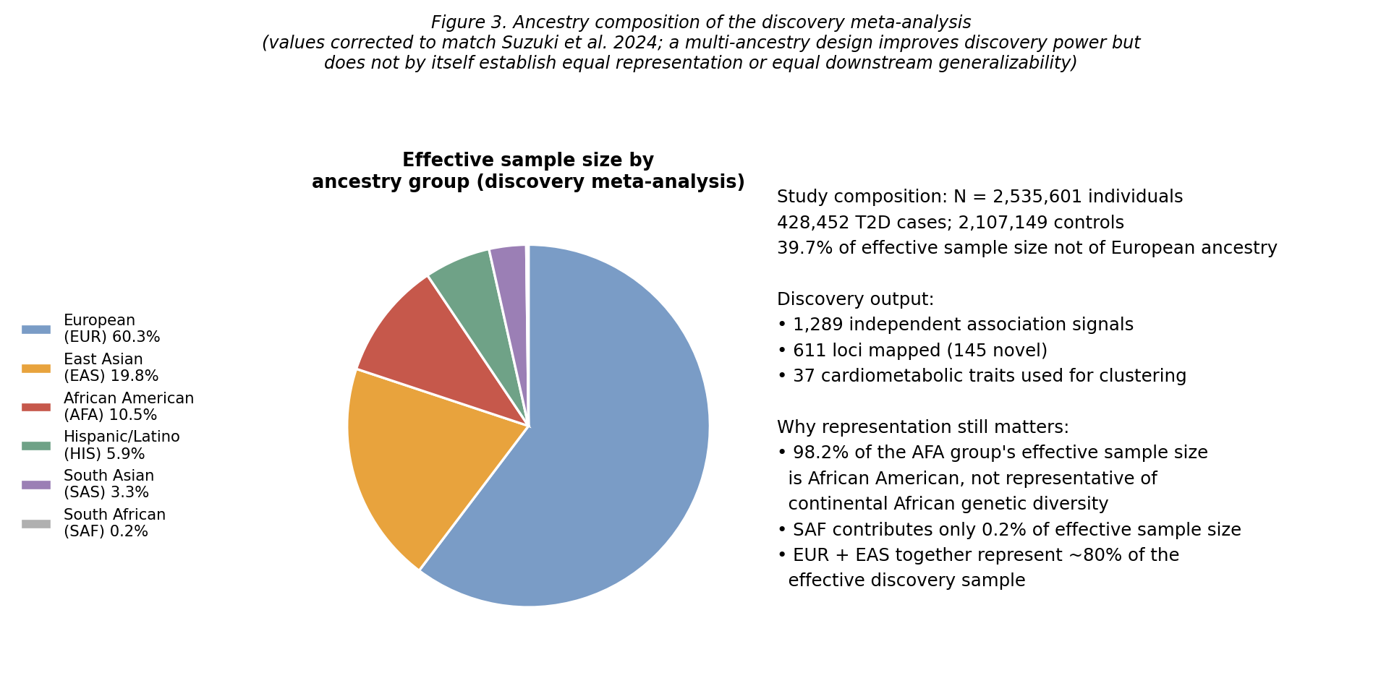
Figure 3. Ancestry composition of the discovery meta-analysis, per Suzuki et al. (2024): EUR 60.3%, EAS 19.8%, AFA 10.5%, HIS 5.9%, SAS 3.3%, SAF 0.2%.

8. Strengths and Limitations

8.1 Strengths
- The partitioned-PS testing sample was deliberately excluded from discovery, protecting the cluster-outcome associations from simply re-discovering the data used to build the clusters.
- Clustering and chromatin enrichment draw on independent data modalities, so the enrichment result is a genuine out-of-sample check on the clustering rather than a restatement of it.
- Ancestry is modeled as continuous structure via MR-MEGA rather than discrete bins, which is what makes the ancestry-heterogeneity analysis in Section 7 possible and avoids reinforcing a false discreteness in human genetic variation.
- Negative and marginal results are reported rather than omitted: no enrichment for body fat and liver/lipid metabolism, small partitioned-PS effect sizes, weaker average allelic effects in the newly identified clusters.

8.2 Limitations
Acknowledged by the authors: hard clustering may not fit outlying or intermediate-profile SNVs well; newly identified clusters carry weaker average allelic effects than previously reported ones; partitioned-PS effects are described as small; the meta-analysis does not fully capture global genetic diversity, particularly in Africa, South and Central America, the Middle East, and Oceania.
From my own reading: no per-SNV cluster-assignment confidence is reported, so the practical scope of the pleiotropy concern in Section 4.1 cannot be quantified from the material available. No missingness rates are reported for the clustering input matrix. No head-to-head discrimination or reclassification comparison is presented for the overall versus partitioned PS. The BMI adjustment for ancestry heterogeneity is ecological rather than individual-level. None of these amount to a fatal flaw; together they bound how far the word “mechanistic” can be pushed without overstating what the evidence chain actually establishes.

9. Reproducibility
Summary statistics from both the multi-ancestry and ancestry-specific meta-analyses are stated as available through the DIAGRAM Consortium website, and the paper lists specific public software and R packages used at each stage (MR-MEGA, METAL, PLINK, ClustImpute, NbClust, factoextra, logistf), most with version numbers. This is a reproducible-in-principle pipeline for a reader with the resources to reconstruct it. From the material available, I could not determine whether the specific ClustImpute run (random seed, iteration count, convergence criteria) is documented precisely enough to reproduce the exact eight-cluster partition rather than a broadly similar one, or whether the individual-level cohort data used for partitioned-PS testing (All of Us, Biobank Japan, Genes & Health, TIMI trials) are accessible to external researchers or restricted under data-access agreements, which is common for clinical data but would limit independent reproduction of that stage.

10. My Critical Perspective
I find the evidence for T2D genetic heterogeneity convincing. The clustering is data-driven, and the chromatin-accessibility evidence meaningfully strengthens the biological interpretation because it comes from an independent data source and produces a pattern — islet enrichment for the beta-cell clusters, adipocyte-only enrichment for lipodystrophy — that lines up with what is already known about T2D pathophysiology. I also find the partitioned-PS findings scientifically interesting in their own right: they suggest that how genetic risk is structured, not just how much of it a person carries, may matter for which complications they develop. That is a more interesting result to me than the raw locus-discovery count, because it is a claim about architecture rather than volume.
What I am not convinced of is that the eight groups should yet be called established mechanistic clusters. My concern is not that hard clustering was the wrong choice — given the missing-data constraints described, it is a defensible one, and the authors' stated reasons for choosing it over soft clustering are real engineering trade-offs, not shortcuts. My concern is that the discreteness of the algorithm's output is being read as evidence of discreteness in the underlying biology, and those are not the same claim. A hard-clustering algorithm will produce eight clean, non-overlapping groups whether the true structure is eight clean subtypes or a continuum with eight convenient cut points imposed on it; the algorithm's output cannot, by itself, distinguish between those two possibilities. The one robustness check the paper reports — comparable centroid disparity between new and previously reported clusters — is suggestive but not equivalent to a stability analysis under resampling or a comparison against soft cluster membership.
I would have more confidence in the eight-cluster model if its structure were shown to survive under a different clustering approach or under exclusion of the most missingness-heavy phenotypes and SNVs. I do not know whether it would. That uncertainty, rather than a settled objection, is the honest place to leave this critique.

11. What Would Change My Mind
- The eight-cluster structure remaining largely stable under repeated k-means initialization and bootstrap resampling of the SNV set.
- A soft/probabilistic clustering run on the same phenotype matrix producing a broadly similar partition, with most SNVs receiving high-confidence membership in a single cluster.
- Functional validation — eQTL colocalization or a perturbation experiment — linking a specific cluster-assigned variant to a specific regulatory and phenotypic effect in the enriched cell type.
- A direct discrimination or reclassification comparison showing the partitioned PS improves prediction of CAD or ESDN beyond the overall PS.

12. Potential Research Extensions

Extension 1 — Cluster assignment confidence
Limitation: no per-SNV measure of how confidently a variant belongs to its assigned cluster. Research question: what fraction of the 1,289 index SNVs sit near a cluster boundary? Method: using the publicly available multi-ancestry summary statistics from the DIAGRAM Consortium, reconstruct the 37-phenotype z-score matrix for a representative subset of index SNVs and compute each SNV's distance to its first- and second-nearest centroid under a re-run of the described pipeline. Evidence generated: a distribution of assignment margins. Interpretation: a long tail of near-tied SNVs would support the pleiotropy concern in Section 4.1; a strongly bimodal distribution would weaken it.

Extension 2 — Hard vs. soft clustering
Limitation: hard and soft clustering were never directly compared on this dataset. Research question: does a probabilistic clustering approach applied to the same phenotype matrix reproduce a similar eight-group partition, or redistribute meaningful membership weight across clusters? Method: implement an NMF-based or similar soft-clustering approach on the same public summary statistics and compare resulting cluster composition and chromatin-enrichment results against the published eight clusters. Evidence generated: membership-weight distributions and a side-by-side enrichment comparison. Interpretation: convergent results would strengthen confidence in the eight-cluster model; divergent results would indicate the biological interpretation is more sensitive to clustering choice than the paper's single robustness check suggests.

Extension 3 — Incremental predictive value of the partitioned PS
Limitation: no head-to-head predictive-performance comparison between the overall and partitioned PS is reported. Research question: does the partitioned PS provide incremental discrimination over the overall PS for CAD or ESDN? Method: using a publicly accessible biobank with genotype and outcome data (subject to data-access approval), construct both scores from the published cluster-specific SNV weights and directly compare AUC/C-statistic and calibration. Evidence generated: a quantified discrimination difference. Interpretation: this would resolve whether Section 6's detectability difference reflects real incremental clinical value or only added statistical sensitivity at large sample sizes.

13. Questions the Paper Leaves Open
- Would the eight clusters and their downstream chromatin enrichment and PS associations remain materially the same if clustering were restricted to SNVs with complete, non-imputed phenotype profiles?
- If soft clustering produced meaningfully different cluster boundaries, would the CAD and ESDN associations reported for the beta cell +PI and obesity clusters survive, weaken, or strengthen?
- How much of the remaining ancestry-correlated heterogeneity after BMI adjustment (24 signals) reflects genuine biological differences between ancestry groups versus other unmeasured, ancestry-correlated environmental factors?
- What would the eight-cluster partition look like under a GWAS meta-analysis with proportional representation of African, South Asian, and Latin American genetic diversity, and is there any way to estimate the direction of that shift from data already collected?

14. Lessons Learned
Three things from this paper changed how I read similar work. First, tissue or chromatin enrichment establishes biological plausibility, not mechanism — I had been treating enrichment results as closer to confirmatory evidence than they actually are, and separating “regulatorily plausible” from “mechanistically demonstrated” is now something I check for explicitly rather than assume.
Second, an upstream computational choice like clustering constrains every biological interpretation built on top of it, even when later stages use independent data. It is tempting to evaluate the chromatin enrichment and PS results as if the eight clusters were simply given; they are the output of a specific algorithmic choice with a specific known weakness, and that weakness does not disappear just because it becomes harder to see once later stages add independent evidence.
Third, statistical significance, predictive performance, and clinical usefulness are three different questions that a well-powered study can answer very differently for the same result. An odds ratio of 1.04 can be statistically convincing while still leaving its clinical relevance uncertain, and neither the P-value nor the effect size alone tells you which situation you are in — that requires a discrimination or reclassification metric this paper does not provide for this comparison.

15. Connection to My Development as a Bioinformatician
This paper sharpened a specific set of habits I want to build rather than a general appreciation for the field. When a paper builds interpretive weight on an unsupervised clustering step, I want to check for a stability or confidence metric before treating the cluster labels as settled analytic units. When a paper claims one scoring approach reveals more than another, I want to check whether that claim rests on a discrimination or reclassification comparison or only on which comparisons happened to cross a significance threshold — those are different claims, and it is easy to conflate them when skimming a results section. I also want to get more comfortable checking how sensitive a published pipeline's output is to reasonable preprocessing choices, rather than treating a single reported robustness check as sufficient on its own.
The concrete direction I would like to pursue is Extension 2 above: reconstructing this paper's clustering pipeline from the publicly available summary statistics and testing how much the eight-cluster structure changes under a soft-clustering alternative, different missing-data handling, and repeated initialization. I do not yet have the applied experience to know exactly how that project would turn out, but I have enough of the statistical and biological background from working through this paper to know what specific comparison would actually be informative, which feels like the right place to be starting from.

16. Conclusion
This study convincingly establishes that T2D genetic risk, aggregated across the largest and most ancestrally diverse GWAS meta-analysis of its kind, decomposes into statistically distinct clusters of association signals, and that those clusters capture biologically relevant structure, supported by coherent cross-modality enrichment in cell-type-specific open chromatin derived independently of the GWAS data. Partitioned components of a polygenic score built from those clusters carry outcome-specific information, in independent samples, that is not fully captured by an aggregated overall score.
It does not establish that the eight clusters represent a uniquely correct or fully stable partition of what is very likely a partly pleiotropic set of variants, given the absence of reported cluster-stability metrics or a soft-clustering comparison; that any individual cluster corresponds to a confirmed molecular mechanism rather than a regulatorily plausible one; or that the partitioned PS offers superior clinical predictive value over the overall PS, since no head-to-head discrimination or reclassification analysis is presented.
The strongest evidence in the paper is the combination of the independent discovery/testing split and the cross-modality chromatin enrichment, both of which genuinely protect the central heterogeneity claim from being a restatement of the data used to generate it. The most important limitation is the gap between the hard-clustering method used and the stability evidence that method would need to fully justify the word “mechanistic.” This paper reaches convincingly through regulatory plausibility and partial phenotypic relevance, and stops short of demonstrated mechanism and established clinical utility — an honest and still genuinely valuable place for a study at this stage of a research program to stop. A direct clustering-stability comparison and a direct predictive-performance comparison for the partitioned score, both feasible with public data, are what would most meaningfully sharpen how much confidence the eight-cluster model deserves.

References
Suzuki, K., Hatzikotoulas, K., Southam, L., Taylor, H. J., Yin, X., Lorenz, K. M., Mandla, R., et al. (2024). Genetic drivers of heterogeneity in type 2 diabetes pathophysiology. Nature, 627, 347–357. https://doi.org/10.1038/s41586-024-07019-6
Udler, M. S., Kim, J., von Grotthuss, M., Bonas-Guarch, S., Cole, J. B., Chiou, J., et al. (2018). Type 2 diabetes genetic loci informed by multi-trait associations point to disease mechanisms and subtypes: a soft clustering analysis. PLoS Medicine, 15(9), e1002654. (Cited within the reviewed paper as the prior soft-clustering effort discussed in Section 4.3.)
Udler, M. S., McCarthy, M. I., Florez, J. C., & Mahajan, A. (2019). Genetic risk scores for diabetes diagnosis and precision medicine. Endocrine Reviews, 40(6), 1500–1520. (Cited within the reviewed paper's reference list; relevant to the polygenic-score partitioning discussion in Section 6.)
Martin, A. R., Kanai, M., Kamatani, Y., Okada, Y., Neale, B. M., & Daly, M. J. (2019). Clinical use of current polygenic risk scores may exacerbate health disparities. Nature Genetics, 51(4), 584–591. (External literature, not cited by the reviewed paper itself; included for the ancestry-generalizability discussion in Section 7.)

